JAVA OBJECT-ORIENTED PROGRAMMING LAB REPORT
Lab 11: Library Management System
Student Name: Jichichi Clive T
Registration Number: h250254b
Programme: Software Engineering
Course: Object-Oriented Programming
IDE Used: Apache NetBeans IDE
Programming Language: Java
Date: 12/10/2026
1. Exercise Question
Develop a Library Management System in Java that demonstrates object-oriented programming concepts. The system should manage library items and members, support borrowing and returning items, identify overdue loans, search for items by title, and save and load data using CSV files.
The implementation should demonstrate classes and objects, encapsulation, inheritance, abstraction, polymorphism, interfaces, exception handling, collections, streams and file handling.
2. Aim
The aim of this practical exercise was to develop a Java-based Library Management System that applies object-oriented programming principles to the management of library items, registered members and borrowing transactions.
3. Objectives
The objectives of the exercise were to:
- Create classes representing books, DVDs, members and loans.
- Apply encapsulation using private fields and appropriate methods.
- Demonstrate inheritance and polymorphism through an abstract parent class and specialised item classes.
- Define a Borrowable interface for borrowing-related operations.
- Use custom exceptions to handle unavailable items and member borrowing limits.
- Store library items and members using Java collections.
- Search for library items by title using streams.
- identify overdue loans using dates and filtering.
- Save and restore library information using CSV files.
- Test the system through its menu-driven interface.
4. Software and Tools Required
- Apache NetBeans IDE
- Java Development Kit (JDK)
- A computer running Windows
- CSV files for storing library records
5. System Design
The system was designed using separate classes, with each class responsible for a particular part of the application.
5.1 Main Classes
Class | Responsibility
LibraryManagementSystem | Provides the main method and menu-driven interaction.
Library | Manages items, members, borrowing, returning and loan history.
LibraryItem | Abstract parent class containing common item details.
Book | Represents a book and stores its author.
Dvd | Represents a DVD and stores its duration.
Member | Stores member information and active loans.
Loan | Records borrowing dates, due dates and return information.
LibraryStorage | Saves and loads data using CSV files.
Borrowable | Defines borrowing and return operations.
5.2 Custom Exception Classes
The system includes the following custom exceptions:
- ItemNotAvailableException — used when an unavailable item is requested.
- MemberLimitExceededException — used when a member has reached the maximum number of active loans.
5.3 Class Relationship
LibraryItem is the abstract parent class of Book and Dvd. The two subclasses provide their own loan periods: 14 days for books and 7 days for DVDs.
The Library class manages collections of items, members and loans. The LibraryStorage class handles persistent storage so that records can be restored when the application is restarted.
Insert the class diagram in this section.
6. Procedure
The following steps were followed during implementation:
- Created a Java project named LibraryManagementSystem in Apache NetBeans.
- Created the lab11library package.
- Developed the abstract LibraryItem class with common fields and methods.
- Implemented the Book class with an author field and a 14-day loan period.
- Implemented the Dvd class with a duration field and a 7-day loan period.
- Created the Member class to store member details and manage active loans.
- Created the Loan class to record borrowing, due and return dates.
- Defined the Borrowable interface.
- Implemented the Library class to manage library operations.
- Created custom exception classes for borrowing-related errors.
- Implemented LibraryStorage to save and load information using CSV files.
- Developed a menu-driven main class to allow users to interact with the system.
- Compiled and ran the project in NetBeans.
- Tested item listing, member listing, borrowing, returning, searching, overdue checking and persistence.
7. Implementation and Source Code
The system was implemented using multiple Java classes rather than placing all operations in one file.
7.1 Abstract Class
The LibraryItem class stores the common item ID, title and availability status. It also declares the abstract loanPeriodDays() method, which is implemented by the subclasses.
7.2 Inheritance and Polymorphism
The Book and Dvd classes extend LibraryItem. The Book class returns a loan period of 14 days, while Dvd returns 7 days. Overriding the same method allows the system to obtain the appropriate loan period depending on the actual item type.
7.3 Encapsulation
Private fields are used to protect important information. Constructors validate input values before storing them, while getter methods provide access to required information.
For example, the Book class stores its author in a private final field and rejects an empty author name.
7.4 Collections
The Library class uses Java Map collections to associate item IDs and member IDs with their corresponding objects. A list stores the complete loan history, including returned loans.
These collections support efficient lookup and management of library records.
7.5 Searching and Overdue Loans
The title-search function uses a Java stream to find matching item titles without case sensitivity and sorts the results alphabetically.
The overdue-loan function filters loan records to identify loans that are overdue and have not been returned.
7.6 File Handling
The LibraryStorage class saves items, members and loans in separate CSV files:
- items.csv
- members.csv
- loans.csv
When the application starts, it loads the saved records and reconstructs the availability of items from the active loan records.
Insert screenshots of the relevant source code in this section.
8. Testing and Results
The following tests were performed using the menu-driven application.
Test | Action | Expected result | Result observed
1 | List all items | Registered items are displayed. | Successful
2 | List all members | Registered members are displayed. | Successful
3 | Borrow item B003 using member M002 | The item is borrowed and a due date is displayed. | Successful
4 | List items after borrowing | B003 is marked unavailable. | Successful
5 | Return B003 using M002 | The item is returned successfully. | Successful
6 | List items after returning | B003 becomes available again. | Successful
7 | Search by title | Matching titles are displayed. | Successful
8 | List overdue items | The system checks and displays overdue loans. | Tested
9 | Restart the application | Saved items and members are restored. | Successful
10 | Clean and build the project | The project compiles without errors. | Successful
The test results demonstrate that the main menu operations, borrowing and returning functions, and CSV persistence worked during testing.
9. Sample Test Data
The following records were used during testing.
9.1 Library Items
Item ID | Title | Type | Loan period
B001 | Introduction to Java | Book | 14 days
D001 | Java Programming Tutorial | DVD | 7 days
B002 | Java Fundamentals | Book | 14 days
B003 | Object Oriented Programming | Book | 14 days
9.2 Members
Member ID | Name
M001 | Alice
M002 | Brian
9.3 Borrowing Test
Member M002 borrowed item B003. The system displayed a successful borrowing message and a return date of 29 October 2026. The item was then listed as unavailable. After returning it, the item became available again.
10. Results and Discussion
The completed application provides a menu through which users can add library items, register members, borrow and return items, list overdue loans, search by title, and display all items and members.
The use of an abstract parent class and specialised subclasses reduces duplication by placing common fields and methods in LibraryItem. The different loan periods demonstrate polymorphism.
CSV storage allows records to persist beyond a single program execution. Testing confirmed that previously saved items and members could be loaded when the program was restarted.
The interface is separated into different classes, making the program easier to understand, maintain and extend.
11. Challenges Encountered
During development, a data-loading problem occurred because the storage component used method names that did not match those in the Library class. The issue was resolved by updating the storage implementation to use the existing methods, including getAllItems() and getAllMembers().
The project was then cleaned, built and tested again. The successful build and subsequent menu tests confirmed that the correction resolved the compilation issue.
12. Conclusion
The Library Management System was developed to demonstrate the practical application of Java object-oriented programming concepts. The system uses classes, encapsulation, inheritance, abstraction, polymorphism, collections, custom exceptions and CSV file handling.
Testing confirmed that items and members could be listed, a member could borrow an available item, the borrowed item became unavailable, and returning it restored its availability. The application also supported title searching, overdue-loan checking and persistence of saved records.
The exercise provided practical experience in designing a multi-class Java application and testing its behaviour through Apache NetBeans IDE.
13. Recommendations
The system could be improved further by:
- Completing and testing the Borrowable interface so that direct borrowing and returning also update the loan history consistently.
- Adding stronger input validation to prevent invalid IDs and dates.
- Improving the display of overdue loans by showing the number of days overdue.
- Adding automated unit tests for normal and exceptional situations.
- Enhancing the interface to make it easier for library staff to use.
- Improving the CSV storage design to provide stronger recovery from corrupted or incomplete records.
14. Screenshot Evidence Checklist
Screenshots are attached in the screenshot folder.
15. Appendix
Attach any additional source-code screenshots, test outputs, class diagrams and supporting evidence required by the lecturer.
APPENDIX
Appendix A: Sample Program Output
This appendix presents examples of the output produced by the Library Management System during testing in Apache NetBeans IDE.
A.1 Main Menu
The main menu provides access to the available library operations.
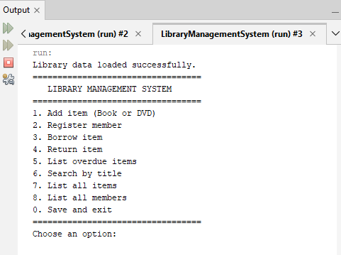
A.2 Listing Library Items
The system displays registered books and DVDs, including their IDs, titles, types, loan periods and availability.
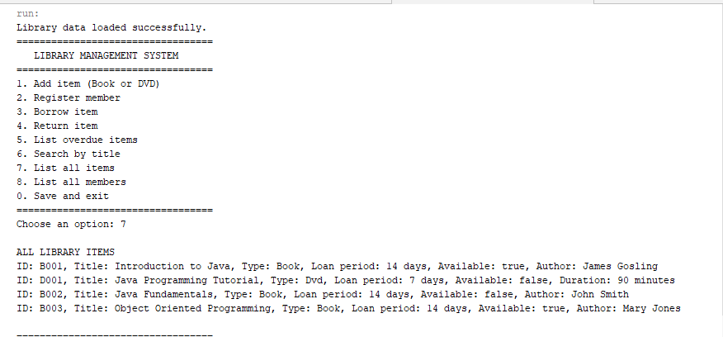
A.3 Listing Registered Members
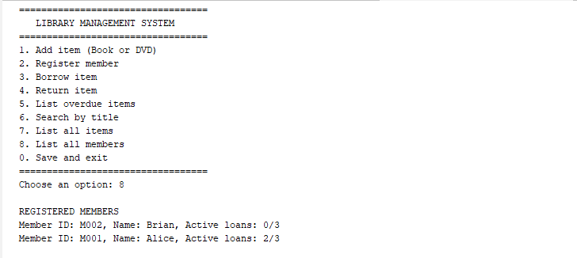
Screenshot A3: Insert the actual screenshot showing the registered members.
A.4 Borrowing an Item
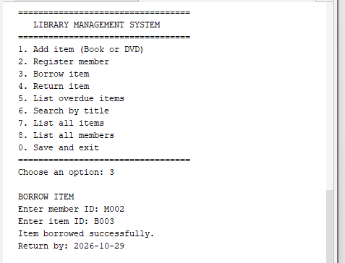The result confirms that the system accepted the borrowing request and displayed the calculated due date.
A.5 Returning an Item
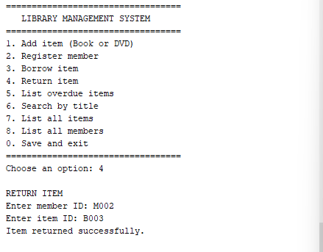
During testing, member M002 returned item B003 after borrowing it. The system confirmed the return and restored the item's availability.
A.6 Searching for Items
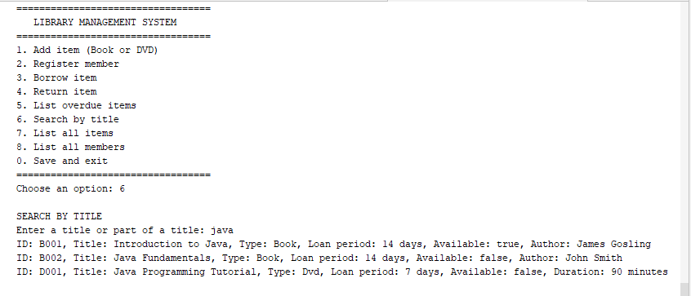
The title-search feature allows users to search for library items using a title or part of a title. The search is case-insensitive and returns matching items in alphabetical order.
A.7 Checking Overdue Loans
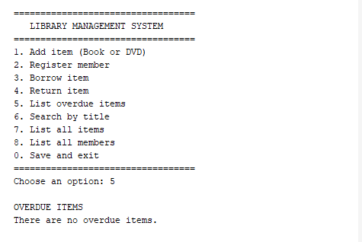
The overdue-loan feature checks active loans to determine whether their due dates have passed. Returned loans should not be included in the overdue list.

